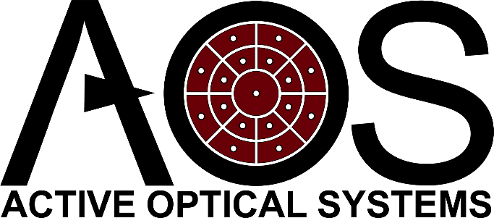
DM Request for Information
Please complete and submit this form to receive information or a quote pertaining to your specified DM performance requirements
The DM Quote Generator is also available to provide rapid cost estimates for AOS Deformable Mirrors (plate-type only)
Customer Information:
Date: Click or tap to enter a date.
Name: Click or tap here to enter text.
Address: Click or tap here to enter text.
Phone Number: Click or tap here to enter text.
Email: Click or tap here to enter text.
Organization: Click or tap here to enter text.
I am interested in: Select

Product Information:
Quantity: Click or tap here to enter text.
Faceplate Diameter (specify units): Click or tap here to enter text.
Number of Actuators: Click or tap here to enter text.
Beam Size: Click or tap here to enter text.
Beam Shape: Click or tap here to enter text.
Coating Type: Select
Angle of Incidence: Click or tap here to enter text.
Volume of DM: Click or tap here to enter text.
Volume of Controller (Associated Electronics): Click or tap here to enter text.
Vacuum or Space Requirements (specify): Click or tap here to enter text.
Cable Length (DM to Electronics): Click or tap here to enter text.
Application & Additional Requirements: (Provide Non-CUI information here)

